ART 3870 PROJECT SUBMISSION TEMPLATE   
complete this template, export to pdf and submit on blackboard

NAME: Francis Rivera

NET ID: MX5987

COURSE: 2017 / WINTER /SECTION 01

Project Title: Personal Homepage

Project Description:

Project URL on github.com: <https://github.com/blackwing415/art3870-wi17.git>

Project URL on github.io: https://blackwing415.github.io/art3870-wi17/index.html

Project Sketches:

(one for each page in the project – scaled to take the whole page width, not distorted/stretched)

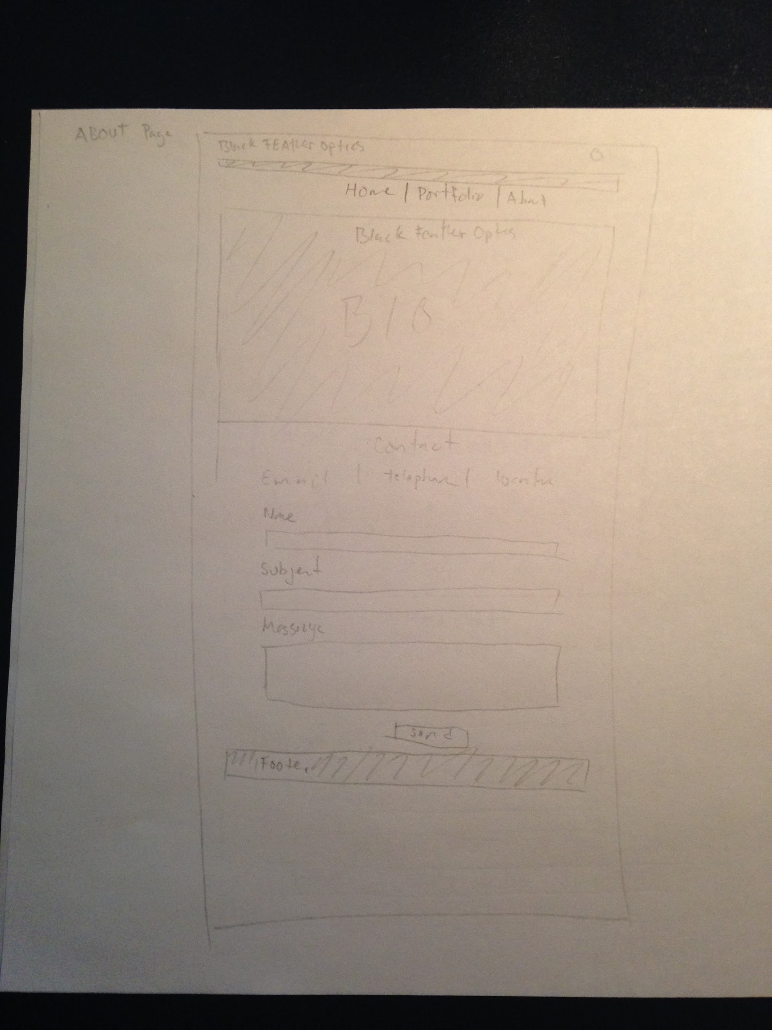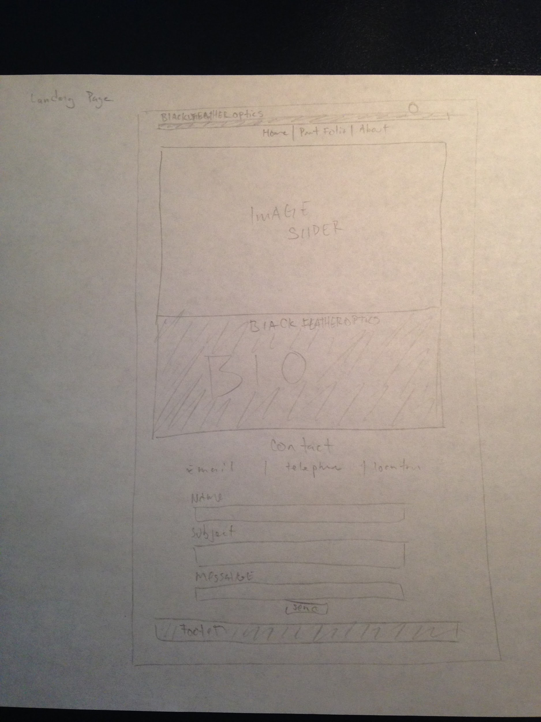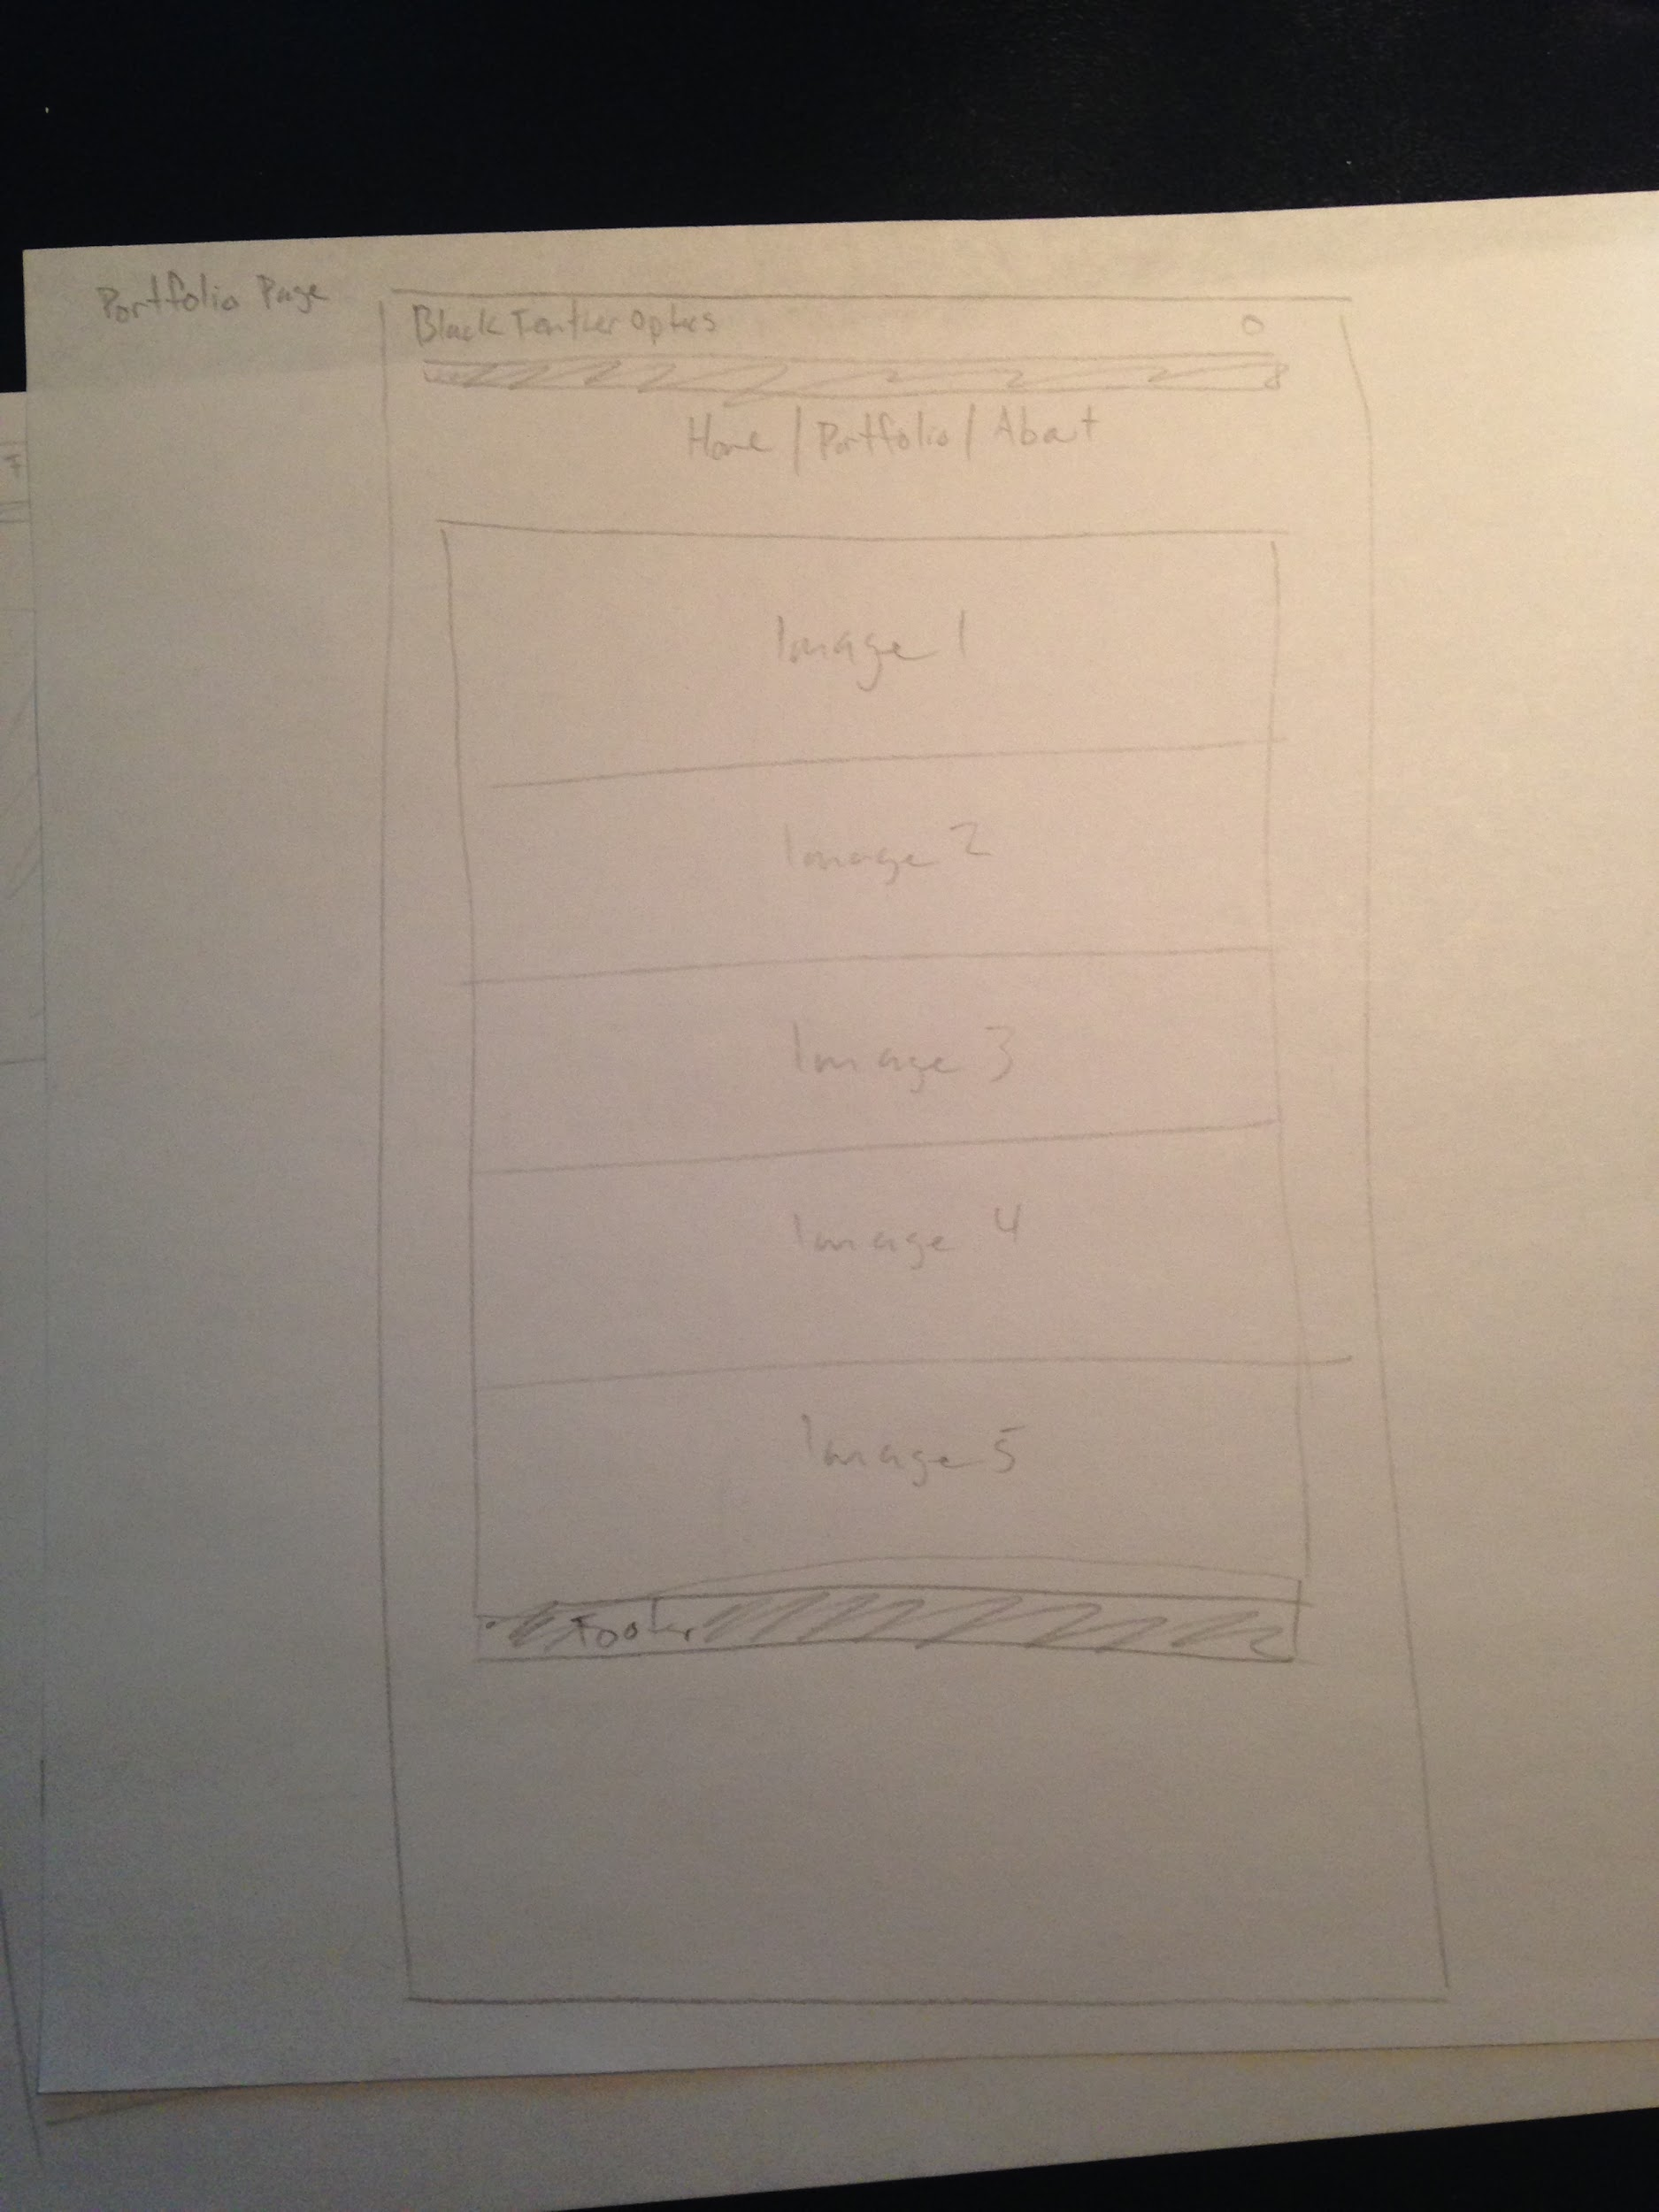

Project Design considerations:

(Explain 3 of your major design decisions)

1. I wanted something simple and modern so I chose a black and white color scheme since this would mainly focus on my photography photos and not have to deal with much.
2. The Portfolio page contains full row length images so you can see the detail and colors without having to zoom in or click through to any other pages.
3. I chose the bio in the about to be a black block with white text to contrast all the white with black text so it would be clean, modern, and still designed in a clean way that was easy to read and navigate,

Project Screenshots:

(one for each page in the project – scaled to take the whole page width, not distorted/stretched)

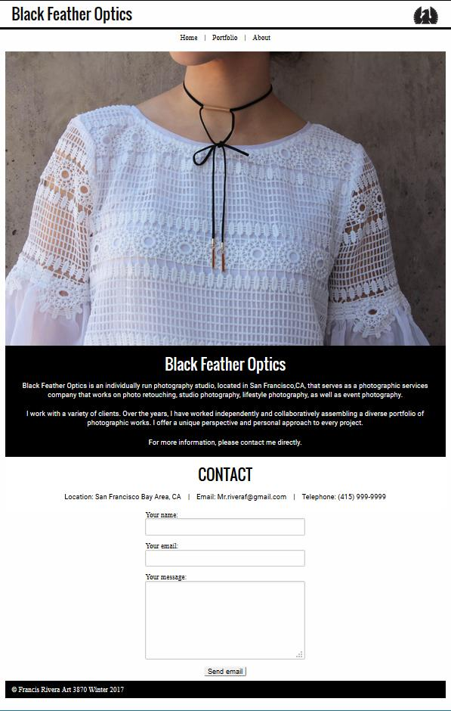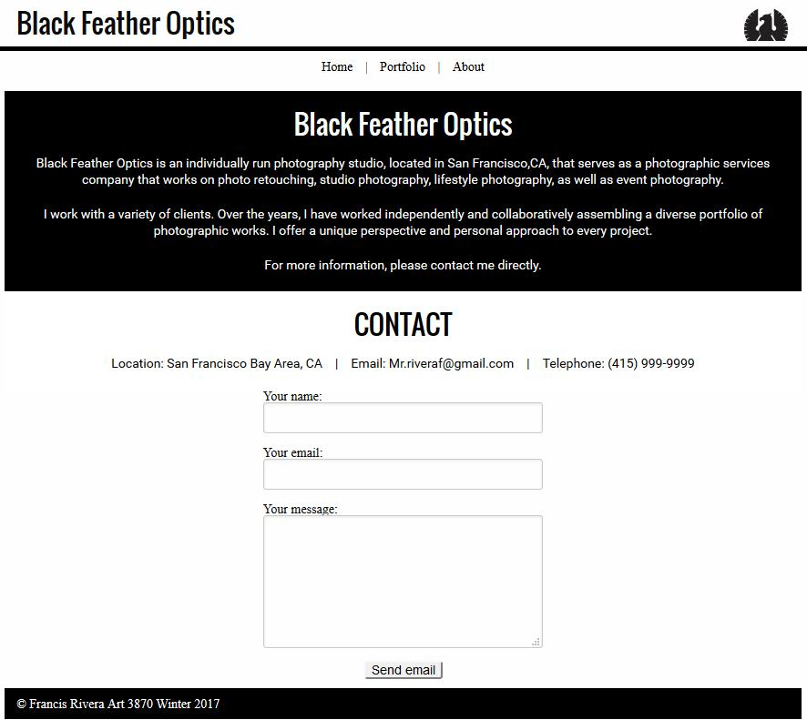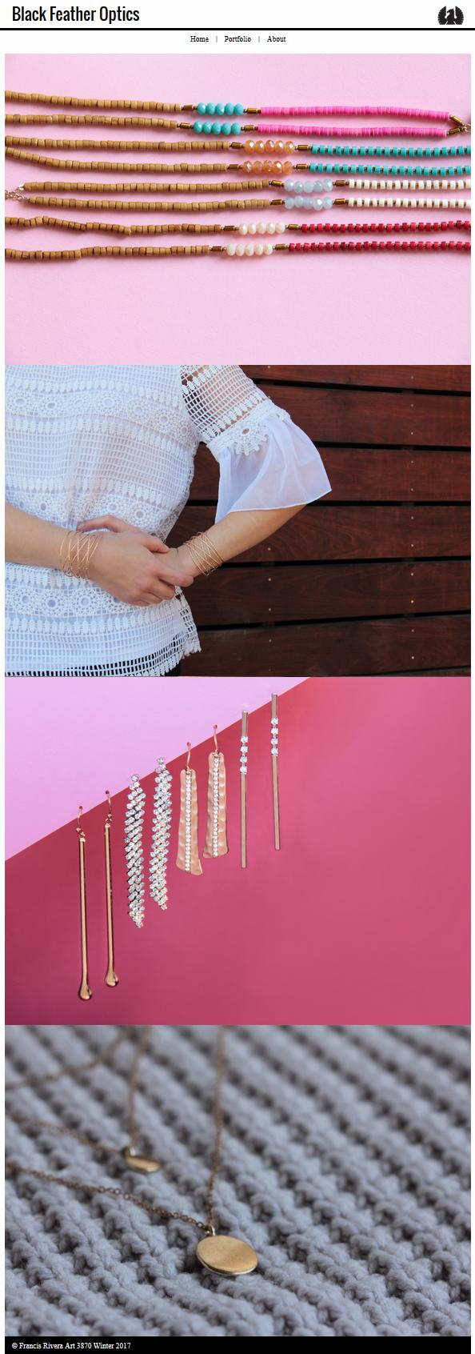

Project Reflection:

(250 words – reflective writing –What was the most challenging part? What was the most exciting part now that the project is done? What did you learn in this assignment, what is your biggest takeaway?)

This project had a lot of problems for me. Two of the main problems were the image slider on the landing page and the contact form layout. For the image slider I spent time looking for some examples that could help me with the code and I happened to find the codes for the images and the javascript. The next problem was to figure out how to size the images so that the look and feel would be elegant in design. With my second problem, I had problems figuring out how to deal with the sizing of the input bars of the contact form. I ultimately gave up and centered the form as it could expand anyway.

The most exciting part of the project was the designing and figuring out to make it. I actually did my sketches after building the full website because I would have stressed out on making everything exact instead of building as i go along.

This assignment was more of a refresher for me in terms of the html and css, but I learned a lot with the process of building it with the “client” interview.

My biggest takeaway for this project was learning how to come up with a clean and modern design that would be flexible for responsive design.